Frontend Development with React.js Project Documentation format.

**Rhythmic Tunes: Your Melodic Companion**

# 1. Introduction

**Project Title: Rhythmic Tunes: Your Melodic Companion**

Team Members: 4

Team Leader Name: **Suriya K**

Team Member Name: Subash I

Team Member Name: Sivanesh

Team Member Name: Selva Ganapathi M

# 2. Project Overview

**Purpose:**

Rhythmic Tunes is a modern music streaming application designed to offer users an immersive listening experience. It provides a vast collection of songs, playlists, and personalized recommendations. The app ensures a seamless interface for browsing, discovering, and enjoying music.

* **Features**:
* Browse Songs by Genre, Artist, or Album
* Personalized Playlist Creation
* Search Functionality with Real-Time Suggestions
* Media Player with Play/Pause, Next/Previous, and Volume Control
* Bookmark Feature for Saving Favourite Tracks
* Light/Dark Mode for Improved User Experience
* Responsive Design for Desktop and Mobile Devices

# 3. Architecture

* **Component Structure:**
* App.js Root component managing layout and routing
* Header.js Navigation bar with search functionality
* SongList.js Displays a list of available songs
* SongCard.js Individual card showing song details and controls
* Playlist.js Manages user-created playlists
* MediaPlayer.js Provides audio playback controls
* Footer.js-Displays copyright and app links
* **State Management**

Context API – Used for managing global states such as theme preferences, playlist data, and bookmarked songs

* **Routing:**

React Router- Implemented for seamless navigation between music categories, playlist views, and song details

# 4. Setup Instructions

* **Prerequisites:**
* Node.js (v18 or higher)
* npm or yarn
* **Installation:**

1. **Clone the Repository:**

‘’’Bash

Git clone <https://github.com/darunraj0071/rhythmic-tunes.git>

Cd rhythmic-tunes

‘’’

1. **Install Dependencies**:

‘’’Bash

npm install

‘’’

3. **Create 'env' file (for API keys or environment variables):**

‘’’env

REACT_APP_MUSIC_API_KEY=your_api_key_here

‘’’

4. **Run the Application:**

‘’’bash

npm start

‘’’

# 5. Folder Structure

**/src**

**/components**

1. Header.js
2. SongList.js
3. SongCard.js
4. Playlist.js
5. MediaPlayer.js
6. Footer.js

/**pages**

1. Home.js
2. Discover.js
3. Playlists.js
4. Favorites.js

**/assets**

1. Images
2. icons
3. styles

**/utils**

1. api.js
2. helpers.js
3. constants.js
4. App.js
5. Index.js

# 6. Running the Application

* **Frontend Server Command:**

‘’’Bash

npm start

‘’’

# 7. Component Documentation

* **Key Components:**
* **Header**: Provides navigation, search functionality, and theme toggling
* **Song List**: Displays categorized or searched songs in a structured format
* **Song Card**: Displays individual song details with play/pause control
* **Media Player:** Controls audio playback, volume, and track navigation
* **Reusable Components:**
* **Button Component**: Used for actions like “Play,” “Pause,” or “Add to Playlist”
* **Modal Component**: Displays song details or playlist creation forms

# 8. State Management

* **Global State:** Managed via Context API for bookmarks, playlists, and theme control
* **Local State:** Managed using React’s ‘usestate()` for track progress, user interactions, and dynamic updates

# 9. User Interface

* Clean, minimalistic Ul designed for seamless navigation
* Fully responsive layout with smooth transitions
* Light/Dark mode toggle for personalized visual comfort

# 10. Styling

* **CSS Frameworks/Libraries:**
* **Tailwind CSS-**Used for fast and modern UI design
* **Theming:**
* Integrated theme switcher for enhanced user experience

# 11. Testing

* **Testing Strategy:**
* Jest for unit testing
* React Testing Library for comprehensive component testing
* Code Coverage:
* Ensured high code coverage with Jest reports

# 12. Screenshots or Demo

# Screenshots:

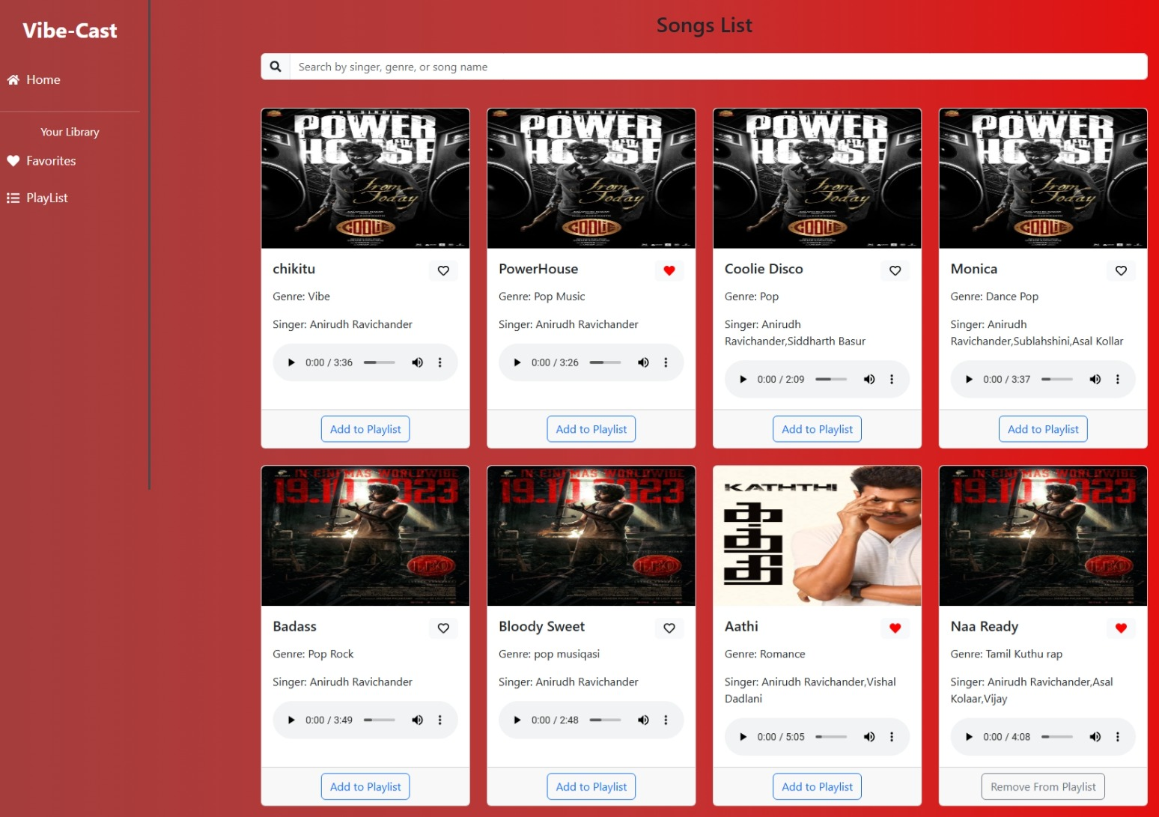

# **Favourites**

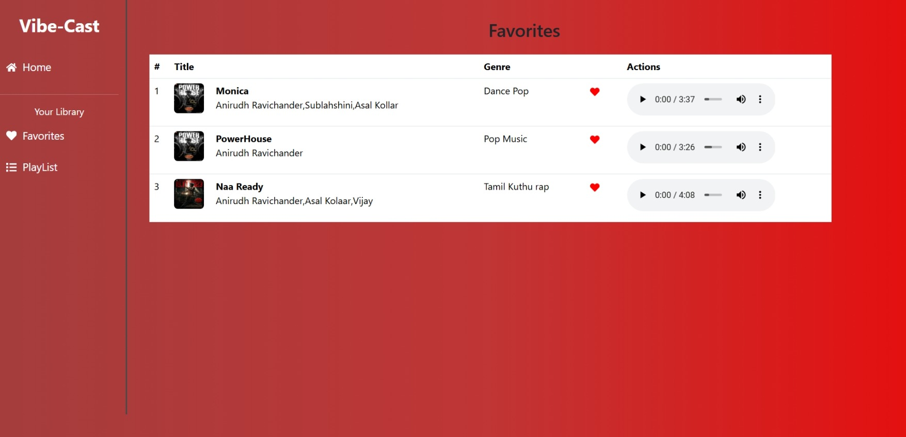

# Play List

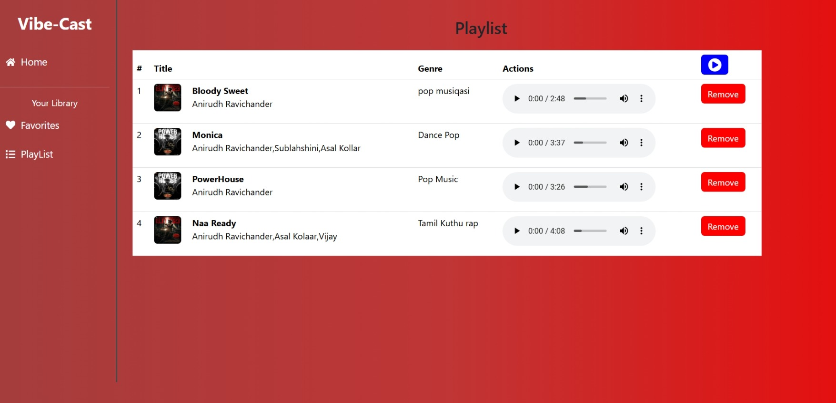

# 13. Known Issues

* Occasional delays in song loading due to API limits
* Playlist feature may require additional optimization for large data sets

# 14. Future Enhancements

* Implement User Authentication for personalized playlists
* Introduce Podcast and Radio Streaming Integration
* Social Sharing Feature for tracks and playlists
* Offline Mode for saved playlists without an internet connection

# 15.Demo Video Link